**SPEED CHECKER TO DETECT RASH DRIVING ON HIGHWAYS**

**ABSTRACT**

The aim of this project is to develop a device to detect rash driving on highways and to alert the traffic authorities in case of any speed violation. Accidents due to rash driving on highways are on the rise and people are losing their lives because of others mistakes. In the present system, to detect rash driving the police has to use a handheld radar gun and aim at the vehicle to record its speed. If the speed of the vehicle exceeds the speed limit, nearest police station is informed to stop the speeding vehicle. This is an ineffective process as after detecting one has to inform the same and a lot of time is wasted.

The proposed system will check on rash driving by calculating the speed of a vehicle using the time taken to travel between the two set points at a fixed distance. A set point consists of a pair of sensors comprising of an IR transmitter and an IR receiver, each of which are installed on either sides of the road. The speed limit is set by the police who uses the system depending upon the traffic at the very location. The time taken by the vehicle to travel from one set point to the other is calculated by a microcontroller program. Based on that time it then calculates the speed and displays that on an LCD. Moreover if the vehicle crosses the speed limit, a buzzer sounds alerting the police.

This concept can be extended in future by integrating a camera with the system which could capture the image of the number plate of the vehicle to sends that to the traffic authorities.

**BLOCK DIAGRAM**

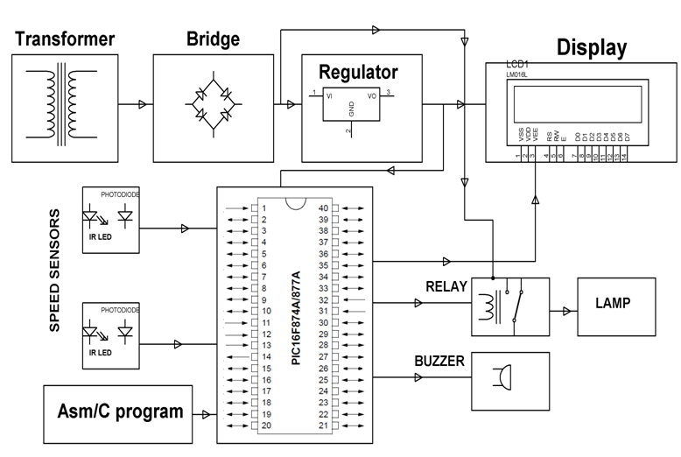

**HARDWARE REQUIREMENTS:**

Transformer, Diodes, Capacitors, Resistors, LEDs, IR, photodiode, Transistor, LCD, Buzzer, Relay, Lamp. PIC series Microcontroller

**SOFTWARE REQUIREMENTS:**

HI-TECH PICC Tool suite

Language: Embedded C or Assembly.